A2018-Czech Republic-Předmostí-Figurine-Mammoth-Ivory-26, 870 BP

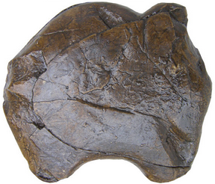 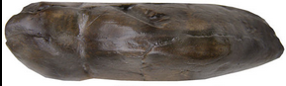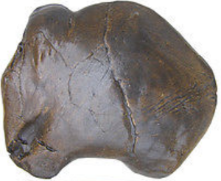

Figs. 1-3. Czech Republic-Předmostí-Figurine-Mammoth-Ivory-26, 870 BP**-**Replica

**Formal Label:** Czech Republic-Předmostí-Figurine-Mammoth-Ivory-26, 870 BP**-**Replica

**Display Description:** This mammoth figurine carved from mammoth ivory was excavated from Předmostí bei Přerov, a cluster of three Upper Paleolithic (Gravettian) sites on limestone outcrops dating to 27,000-24,000 BP, located in Moravia, Czech Republic. The figurine is interesting because it is not meant to be a realistic portrayal but rather a snapshot of the animal in the act of foraging the tundra. It is composed of a single globular volume with carefully distinguishable stylistic features that display the animal with front feet extended forward head and trunk bent , providing an aspect of its behavior that suggests obliviousness to danger. As such, this may have been used as a pedagogical device that was intended to teach inexperienced hunters the pose of the animal when they should take aim with their atlatls.

These hunters were indeed successful at hunting mammoths and other mammals, based on the fact that the hearths within their dwellings have yielded burned bone of over 1,000 mammoths, and added to these were bones of Pleistocene mammals including fox, horse, wolf, bear, wolverine, hare, and dog, and of this latter mammal some were considered possibly domesticated by their physical anatomy (Germonpré *et al.* 2012). Based on this assemblage, the site was used for an extended period of time.

A new interpretation of this mammoth carving as a pedagogical device has been recently proposed by [Alexis Brugère](https://www.sciencedirect.com/science/article/pii/S1040618214003127" \l "!) (2014):

hunting was the main, if not the only, procurement pattern [at Předmostí]. Considering the published data from Pavlov I (Moravia) and the reconstructed age profiles based on mammoth teeth, we suggest the proboscidean was hunted at that site. More unexpectedly, two hunting strategies have been identified in the Pavlov Hills area: one affecting subadults and adults, and the second one affecting young and subadult individuals. Chronology and the physical condition of the mammoth population are not convincing arguments to explain such a difference. Human behaviour was involved, and we suggest economic goals related to mammoth resources were the reasons for such a hunting selection. Nevertheless, it is unclear whether season or human group identity could have produced this behaviour.

**Accession Number:** A000

**LC Classification:** GN772.22.C95

**Date or Time Horizon:** 26, 870 +/- 250 BP

**Geographical Area:** Předmostí bei Přerov, Moravia, Czech Republic, a cluster of three Upper Paleolithic (Gravettian) sites on limestone outcrops.



Fig 4. Předmostí bei Přerov clay dune in which the sites were excavated, photograph by Přerov, archeological locality, Chromeček parcel, 1896. [PD-1923](https://commons.wikimedia.org/wiki/Template:PD-1923)

**Map, GPS coordinates:** 49.467000N, 17.437000E; 49° 27′ 56″ N, 17° 26′ 23″ E.

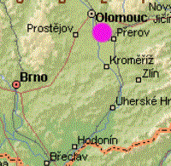 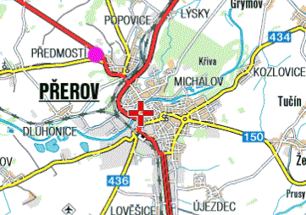

Figs. 5-6. Maps of Předmostí bei Přerov from <http://www.biologus.eu/Predmosti%20%20%20UR%20Karte_soubory/image004.gif>

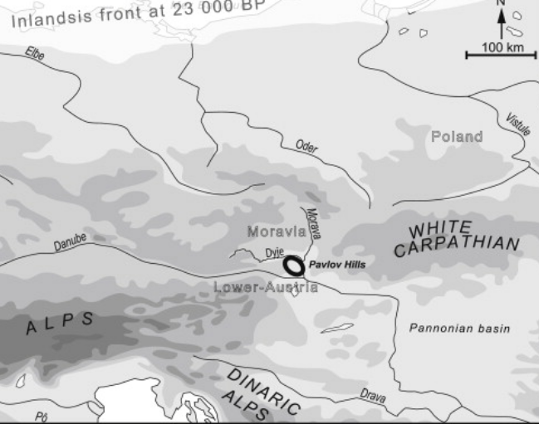

Fig. 7. Location of Předmostí bei Přerov in the Pavlov Hills ([Brugère](https://www.sciencedirect.com/science/article/pii/S1040618214003127" \l "!) 2014).



Fig. 8. Relief map showing Upper Paleolithic sites along the northeast side of the Pavlov Hills. Dark lines are the Dyje River after 1989.

**GPS coordinates:** 49.467000N, 17.437000E; 49° 27′ 56″ N, 17° 26′ 23″ E.

**Cultural Affiliation:** Upper Paleolithic, Gravettian.

**Medium:** mammoth ivory.

**Dimensions: L 11.6 mm, H 10 mm, W 3.3 mm.**

**Condition:** museum replica in resin.

**Provenance:** Moravian Museum in Brno, acc. no. 11671.

**Discussion:**

Accompanying these burned bones were bone tools, figurines and bone artifacts with engravings of animals. The graves that accompanied these sites were few—only about 20. Since these sites were occupied for an extended period it is unexplained why there were only 20 burials (primary, secondary and incomplete) and no red ocher, usually a sign of ritual internments, which led some early researchers to conclude that these burials were evidence of cannibalism a position that has been challenged more recently.

Excavations at Předmostí bei Přerov conducted between 1884 and 1930 were lost in World War II and the recent excavator, Jiří A. Svoboda, has attempted to collate these lost collections by comparing their recorded taphonomy with that of recent excavations (Svoboda 2007, 2008).

“The origin of Gravettian is seen as a more complex process than was thought before, involving an impact of industries with backed blades and bladelets from the eastern Mediterranean (Ahmarian, Lagaman, Dabba, beginning before 40 ky BP). After its establishment in Europe, the Danubian Gravettian is ordered into earlier Pavlovian stage (30-25 ky BP), concentrated in the Austrian-Moravian-South Polish corridor, and later Willendorf-Kostenkian stage (25-20 ky BP), widely dispersed over central and eastern Europe” (Svoboda 2007).

**References:**

[Brugère](https://www.sciencedirect.com/science/article/pii/S1040618214003127#!), Alexis. 2014. “Not one but two mammoth hunting strategies in the Gravettian of the Pavlov Hills area (southern Moravia),” [*Quaternary International*](https://www.sciencedirect.com/science/journal/10406182), [337](https://www.sciencedirect.com/science/journal/10406182/337/supp/C), 9 July, pp. 80-89.

Germonpré, Mietje, Martina Lázničková-Galetová, Mikhail V. Sablin. 2012. “Palaeolithic dog skulls at the Gravettian Předmostí site, the Czech Republic,” *Journal of Archaeological Science,* 39(1):184-202.

Svoboda, Jiří A. 2007. “The Gravettian on the Middle Danube,” *Paleobiology,* 19:203-220.

Svoboda, Jiří A. 2008. “The Upper Paleolithic burial area at Předmostí­: ritual and taphonomy,” *Journal of Human Evolution,* 54(1):15-33.

Velemínská, J., J. Brůžek, P. Velemínský, L. Bigoni, A. Šefčáková, [S. Katina](http://www.sciencedirect.com/science/article/pii/S0018442X07000583). 2008. “Variability of the Upper Palaeolithic skulls from Předmostí ­ near Prerov (Czech Republic): Craniometric comparison with recent human standards,” *HOMO - Journal of Comparative Human Biology,* 59(1):1-26.